CSCI 360 Assignment 3

Mingzhe Fang

5301084138

Nov.16

Part1

Problem1.

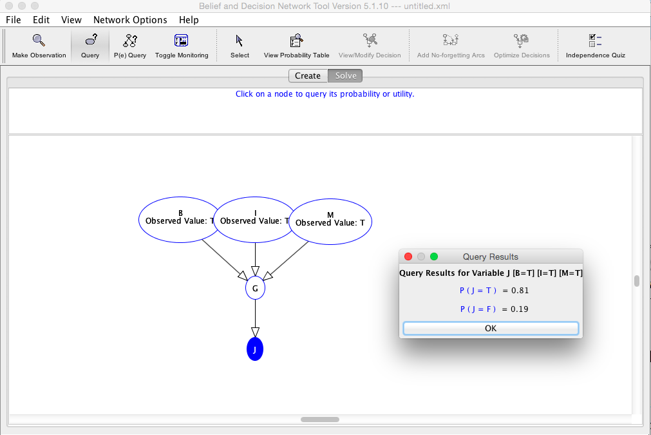

Problem2.

The addition variable P = PresidentialPardon will affect variable J directly, so here we will add another arc from P to J directly. Since the Personal may still be found guilty even P is set true, so P doesn’t necessarily affect the value of G. Therefore we didn’t add another link between P and G.

If P=true, than J is false regardless of other variables’ value. Everything stays the same.

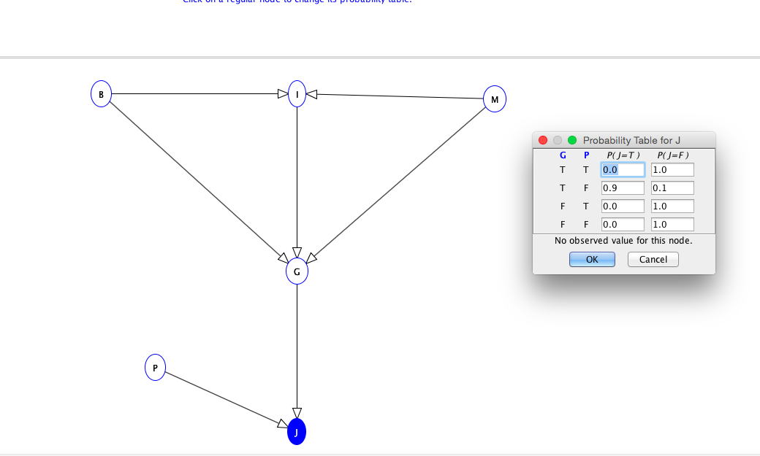

Problem3

Donald Trump Problem

I assumed that the following factors might affect the chances that Trump gets elected as President.

One of the known probability scenario is if ISIS attacks main city in USA and Trump is assassinated by ISIS people at the same time, the chances that Trump is selected to be President is going to be 0;

Another scenario might be that China applies new economic restriction on USA in facing with Trump’s economic policy and Mexican Immigrants started strikes on USA, the chances that Trump is selected as President is going to drop to 0;

